Eventi
Use Case Specification

Submitted to:

Asst. Prof. Ma. Rowena C. Solamo
Faculty Member
Department of Computer Science
College of Engineering
University of the Philippines, Diliman

Submitted by:
Dimaano, Aaron Diego I.
Lopez, Matthew S.
Torres, Jacob Angelo V.

In partial fulfillment of academic requirements
for the course
CS 191 Software Engineering I
of the
1st Semester, AY 2015-2016
Unique Reference:
The documents are stored in https://github.com/Tom-2013-06417/CS191-192_Event_Sharing/tree/master/02-Requirements%20Engineering.
Link to this document:

Document Purpose:
The purpose of this document is to exhaust the step-by-step process of the Use Cases in every scenario possible.

Target Audience:
To our project client and adviser, our fellow 191 classmates, and our future selves when they need to refer back to this document.

Revision Control:

Revision Date | Person Responsible | Version  Number | Modification
09/18/15 | Dimaano, Diego  Lopez, Matthew  Torres, Jacob | 1.0 | Initial Document

Use-Case Name: View event details

Description: This is a drop-down feature of the after-search page. The users would see the important details of the event, including tags, and the organization itself. Users may see a small statistic indicating how many people are going to the event.

Preconditions: The user can see the displayed events in the home page or in the results page after searching.

Flow of Events:

Scenario Name | Description
Scenario 1 (Basic Flow)  Users views an event tile from the home page | - User expands an event on the home page  - User sees the event details, including the organization responsible
Scenario 2  Users views an event tile from the results page after searching | - User expands an event on the search page  - User sees the event details, including the organization responsible

Activity Diagram of the Flow of Events:

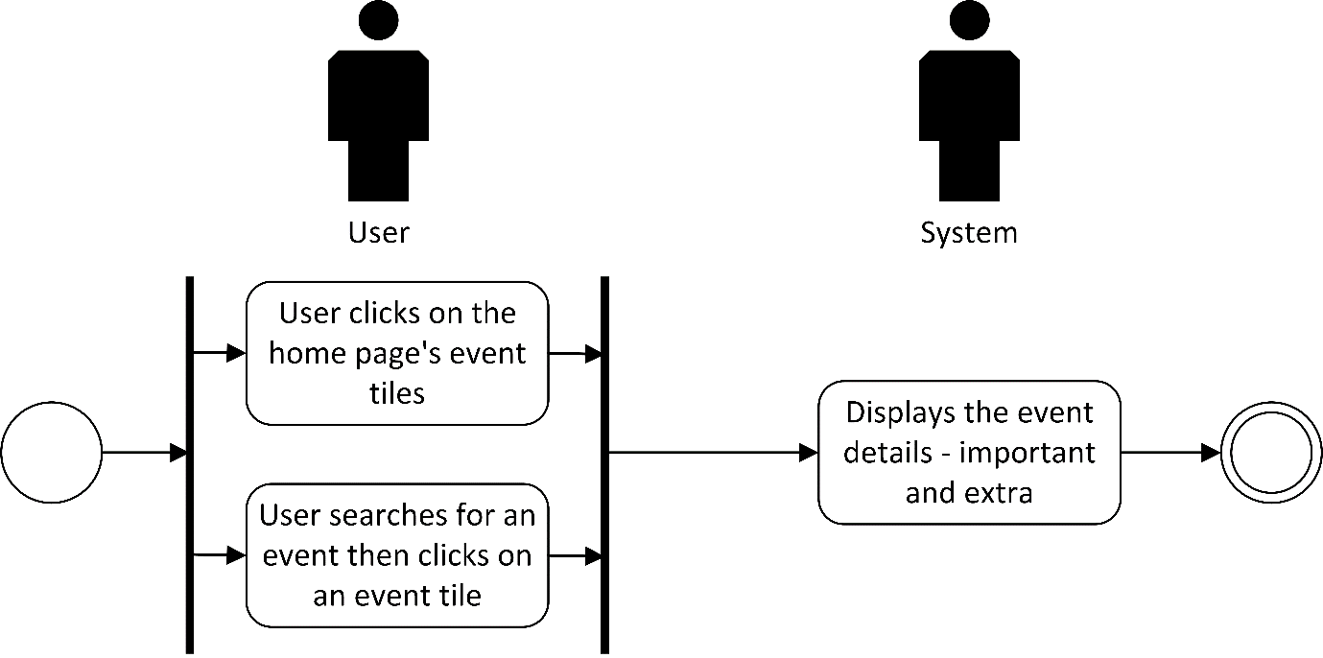

Post-conditions: Successful: The event details displayed.
Failed: The website did not load.

Special Requirements: NONE

